Assignment 2
Submitted By : Vikram Singh Chandel
Roll No: 173040020

Question 1
a)
rm(list=ls())
#install.packages("xlsx")
require("xlsx")
setwd("/home/de/Dropbox/Hydroinformatics/Assignment 2/")
raw_data=read.xlsx("Temp_173040020_26.5_78.5.xls",sheetIndex = 1,header = FALSE)
summary(raw_data)
YearRain=raw_data[ ,c(1,4)]
annav=matrix(c(0),nrow = 34,ncol = 2)

for(i in 1:34){
ind = which(raw_data[ ,1]==1979+i)
annav[i,1]=1979+i
annav[i,2]=mean(YearRain[ind,2])
}

Variable ‘annav’ contains Year and Annual Mean Temperature.

b)
dataF=data.frame("Year" = annav[ ,1],"ANMTEMP" = annav[ ,2])
mfit=lm(ANMTEMP~Year,dataF)

Intercept (𝛽₀) | -46.42202
Slope(𝛽1) | 0.03809
SE of 𝛽0 | 41.13844
SE of 𝛽1 | 0.02061
Sigma Hat: | 1.179
R-squared: | 0.0965
t-value for slope 𝛽1 | 1.849
p value for slope 𝛽1 | 0.0738

Hypothesis testing:
Null Hypothesis: 𝛽₁=0
Alternate hypothesis: 𝛽₁ != 0

tobserved=1.849 (from R output and can be calculated manually)
tcritical for 99% confidence level is 2.738

As tobserved < tcritical so we have no evidence to reject null hypothesis

Command to find R² from model is
summary(mfit)$r.squared

c)

conf=predict( mfit, data.frame( Year= 1980:2013 ) ,interval ="confidence" , level = 0.99 )
pred=predict( mfit, data.frame( Year= 1980:2013 ) ,interval ="prediction" , level = 0.99 )
plot(annav[ ,1],annav[ ,2],xlim = c(1980,2013),ylim = c(25,40),xlab="Years",ylab = "Annual Mean Temperatures(°C)",main="Regression Plot")

#plot fit line
abline (mfit , lwd =1,col="red")

#plot confidence interval
lines(1980:2013,conf[ ,2],col="black",lwd=1)
lines(1980:2013,conf[ ,3],col="black",lwd=1)

#plot prediction interval
lines(1980:2013,pred[ ,2],col="black",lwd=1,lty=4)
lines(1980:2013,pred[ ,3],col="black",lwd=1,lty=4)

legend("topright",c("Prediction interval(99%)","Confidence interval(99%)","Fitted Line"),lty=c(4,1,1),lwd=c(1,1,1),col=c("black","black","red"))

#optional
x=seq(-4,4,0.1)
plot(annav[ ,1],annav[ ,2],xlim = c(1980,2013),ylim = c(25,35),xlab="Years",ylab = "Annual Mean Temperatures(°C)",main="Regression Plot")
#plot(x,dnorm(x,0,summary(mfit)$sigma),type = 'l',xlim=c(-4,4),ylim=c(0,0.4))
polygon(1982+5*c(0,dnorm(x,0,summary(mfit)$sigma),0),pred[2,1]+c(-4, x, 4), col='gray95')
polygon(1990+5*c(0,dnorm(x,0,summary(mfit)$sigma),0),pred[10,1]+c(-4, x, 4), col='gray95')
polygon(2000+5*c(0,dnorm(x,0,summary(mfit)$sigma),0),pred[20,1]+c(-4, x, 4), col='gray95')
abline (mfit , lwd =1,col="red")
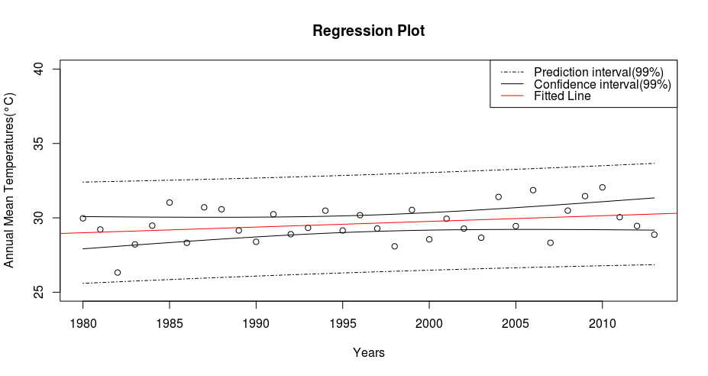
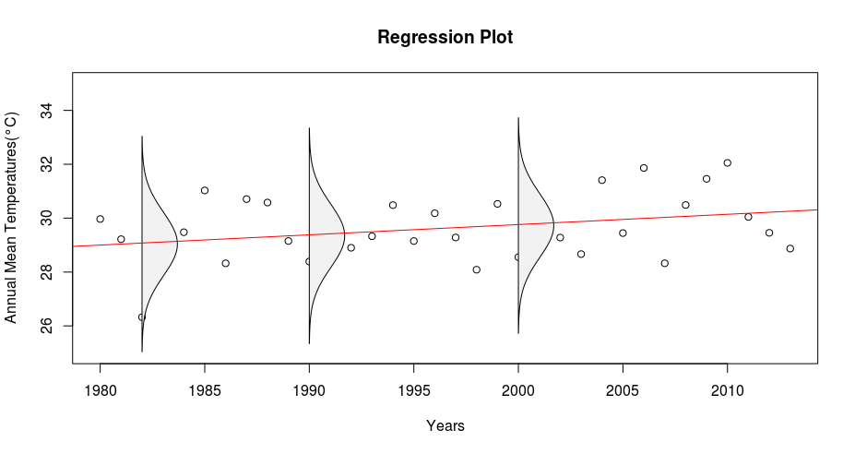

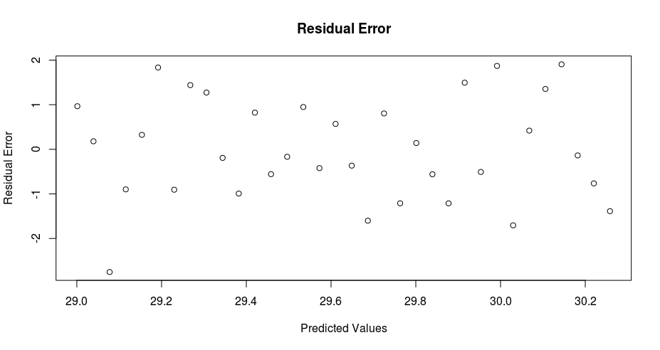
Both the intervals are narrower near the mean and wider at the end of training data set
d)
plot(pred[ ,1],summary(mfit)$residuals)

Variation of residual errors with Y is random hence model fitted is appropriate

e)
The output of fitted glm is similar to linear regression because linear regression is a special case of glm.

a)
rm(list=ls())
#install.packages("xlsx")
require("xlsx")
setwd("/home/de/Dropbox/Hydroinformatics/Assignment 2/")
raw_data=read.xlsx("Temp_173040020_26.5_78.5.xls",sheetIndex = 1,header = FALSE)
summary(raw_data)
YearRain=raw_data[ ,c(1,4)]
annav=matrix(c(0),nrow = 34,ncol = 2)

for(i in 1:34){
ind = which((raw_data[ ,1]==1979+i))
ind2= which(raw_data[ind,4]>33)
annav[i,1]=1979+i
annav[i,2]=length(ind2)
}

b)
GLM0 :: Y=B0
GLM1 :: Y=B0 +B1*X

 | GLM0 | GLM1
𝛽0 | 2.72939 | -25.798957
𝛽1 | - | 0.014284
SE of 𝛽0 | 0.04381 | 8.974419
SE of 𝛽1 | - | 0.004492
t-value for b0 | 62.3 | -2.875
P value b0 | <2e-16 | 0.00404
t-value b1 | - | 3.180
P value b1 | - | 0.00147
AIC | 238.56 | 230.39
BIC: | 240.0894 | 233.4439
Log likelihood | -118.2815 | -113.1956

Hypothesis testing:
Null Hypothesis: B1=0
Alternate hypothesis: B1 not =0
t value observed for B1 is 3.18 and for 95% confidence level t value is 2.036933 (which is less than 3.18 observed and p value is 0.001631429 hence we can reject null hypothesis

c)
Dobs=10.177

D01=2*(logLik(gfit2)-logLik(gfit1))

P value for deviance is 1- pchisq(D01, df = 1)

=0.001426013

Moreover Dcirtical=6.634897 for 99% confidence level

As Dobs>Dcrit , we can reject GLM0 in favour of GLM1

